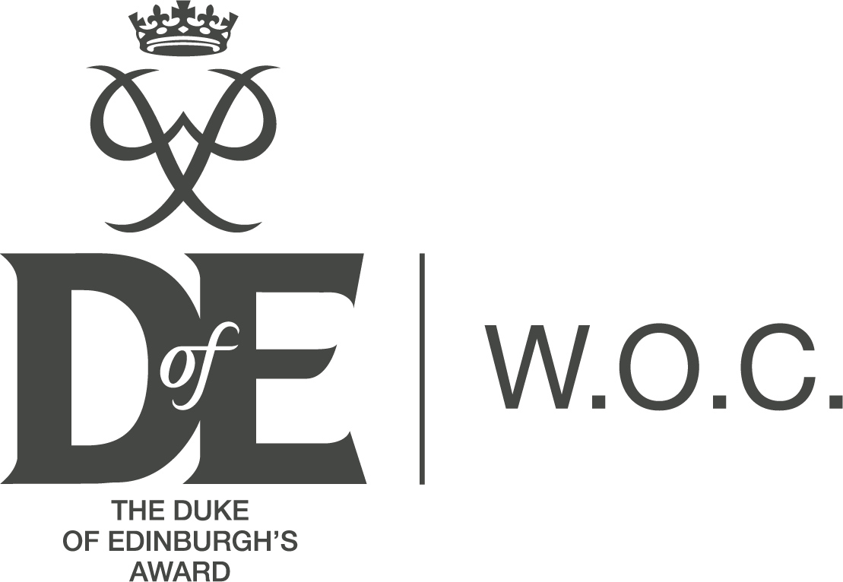

2022
  - YEAR IN REVIEW
 | Warehouse Open Centre |  | info@woc.org.uk

“W.O.C. 2022”
Welcome to the Annual Report of the Warehouse Open Centre.
This report highlights the activities of the past year and our plans for the future.

Staffing

Volunteers

The Warehouse is staffed totally by volunteers, without them the centre could not run or function.

Through out the year our volunteers were Brian Bibby, Jenny Simon, Fran Duff, April Heaney, Mark Shaw and we have been recently joined by Leanne Massey and Evan Shaw.

The first thing I would like to do is to record my thanks to the leaders for all their time and dedication.
Figure 1

Leaders Training

All volunteers complete an “Introduction to the DofE” training course run by the DofE Award Scheme. This course gives a broad introduction to how the Award works and general information about each of the 5 sections: Physical, Skills, Expedition, Volunteering and at Gold an additional Residential.

Additional training is available for Leaders involved in expedition work. This starts with BES (Basic Expedition Skills for Bronze), Hill walking qualifications, ML1&2, Expedition supervision and assessing. All Qualifications are subject to regular revalidation.

All leaders involved in expedition work receive Rescue Emergency Care First Aid training which is a 16 hour course revalidated every three years.

All Leaders undergo Access NI Checks, with thanks to GPH Consultants for processing these. Child Protection training is carried out on an annual basis.

.

Our Young People

Numbers at the Warehouse Open Centre have continued to grow over the years, and we have managed to keep numbers up through out the pandemic by switching to online meetings.
Currently we have 90 young people registered across all levels of the Award.

From 1st Jan 2022 to 31st Dec 2022 the following have been awarded
Bronze 10
Silver 5
Gold 2

Program

This year we have been able to get back to face to face meetings with the young people.
We have spent a few nights on each section (Skills, Volunteering, Physical) to help develop new ideas and interests for the participants to engage in.

We have also started to broaden some offerings from the Warehouse to help young people get involved in new Skills. Thanks to the Diamond Award funding we were able to purchase several digital cameras to help the participants to learn photography with Fran.

We have been able to sign post and help young people in other sections of their award in the areas of volunteering and physical activities.
Aim  To help young people  Achieve their potential and complete their DofE award | Skills  We aim to help impart soft skills training to young people and encourage them to self-reflect on their progress and achievements. |  | Achievements  We take pleasure and pride in seeing young people completing their DofE Awards at all levels.

Expedition

The Expedition section is one of the most resource intensive areas of DofE training.

Our training program for Participants starts in January and runs to May, covering all theory aspects of doing an expedition safely.

The topics covered include practical sessions on how to cook, pack a rucksack, choose equipment, basic first aid and navigation.

Over the last two years, thanks to grants, we have been able to refresh a large proportion of our expedition supplies and tents providing our participants with modern and light weight equipment.

Gaining a healthy respect for the outdoors and our local environment

Following the theory training a practice expedition was run in the Mournes for silver and gold participants.
The aim of these practice expeditions is to let the young people put their theory training into practice and experience wild camping, many for the first time, in real conditions (the one thing we can’t supply is good weather)

For the final expeditions this year we were able to support and equip 2 Silver and 2 Gold expeditions in the Antrim Hills. All participants put in a fantastic personal effort to complete their expedition challenge.
The silver groups walked for three days and camped for two nights, and the Gold groups walked for four days and camped for three nights.

A big thank you is also due to the leaders who were on location for the duration of the expedition to provide supervision, encouragement and support for the participants. This was a massive time commitment and appreciated by all.

Finance

As a centre we try to keep our costs to a minimum for all participants.
Again, for the 2022 season we have been able to keep our fees at the same rate.

We are thankful for equipment grants received from The DofE Diamond fund and for financial support for running costs from Ards Borourgh Council community relations funding.

We are in the fortunate position that we can offer free place vouchers for those most in need.

Expeditions are our biggest expense, with a qualifying expedition costing in the region of £800 to run and cover. Insurance is additional to this costing at just under £600 for the year.

Leader training is another area that we provide for, First Aid training costs £150 each and Mountain Leadership training costs up to £800.

We again are thankful to grant funding from the DofE to subsidize the cost of some of this training.

